INSTALLATION – Short Version:

The Makino post consists of four (4) files: Makino.def
Makino.pui
Makino.tcl
Makino_Post_Options.tcl

Load the Makino.def, Makino.pui, and Makino.tcl files into your common post folder and add an entry for this post in the template_post.dat file. Then place a copy of the Makino_Post_ Options.tcl file into the same folder that the template_post.dat file is in.

INSTALLATION – Detailed Version:

1. Create a new directory (folder) on your system which will be used to store/hold all of your posts. It is preferable to make this folder outside of the NX4/NX5 directory so that subsequent versions of UG don’t overwrite the posts. For my example, I will create a new folder called UGPOSTS at the top-level of my C-drive. Thus the path will be as follows: C:\UGPOSTS

2. Copy the four post files (Makino.def, Makino.pui, Makino.tcl, Makino_Post_ Options.tcl ) into this new folder.

3. At this point we are ready to edit the file that tells UG where to look for the posts. This file is located in the resource\postprocessor folder of your MACH directory. If you do not know where your MACH folder is located, you can determine its location by starting NX and selecting Help → NX Log File from the top menu bar:

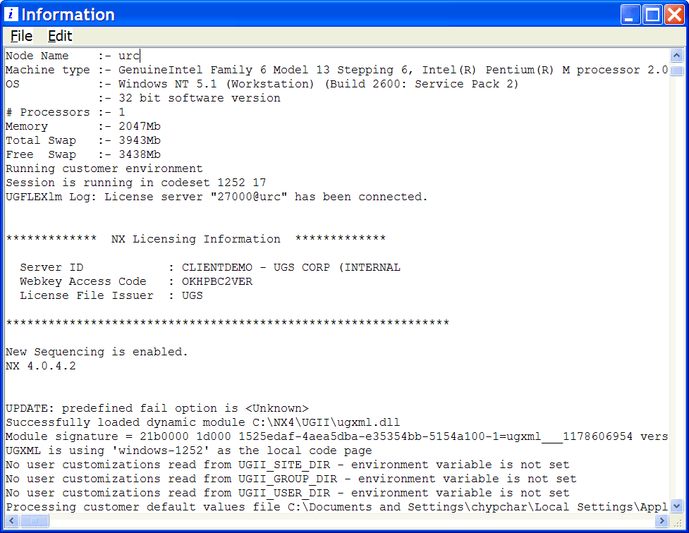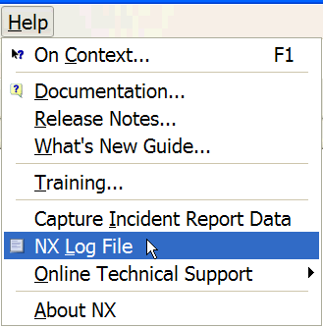
Now search for UGII_CAM_BASE_DIR - this variable shows the location of your NX MACH folder:

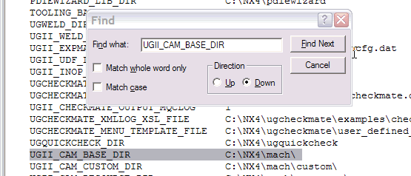

I don’t know where your UG software is loaded – in any case, if your location is different than mine, substitute the correct path, where appropriate, as per my example. Using your windows explorer, locate the following NX directory: ...\MACH\resource\postprocessor (as I said earlier, your MACH folder may be in a completely different location).

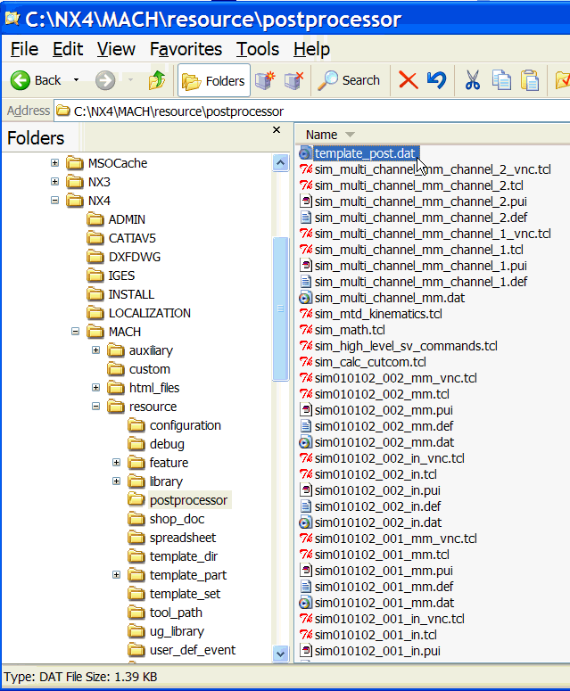
4. In this directory you should find a file called: template_post.dat:

Edit this file using Notepad. Its contents will look similar to this (there may be different entries, but that’s okay, it doesn’t affect what we are going to do ):

###############################################################################
# template_post config file - Event Handler and Definition files for
# Generic Machine
#
#
#
###############################################################################
WIRE_EDM_4_AXIS,${UGII_CAM_POST_DIR}wedm.tcl,${UGII_CAM_POST_DIR}wedm.def MILL_3_AXIS,${UGII_CAM_POST_DIR}mill3ax.tcl,${UGII_CAM_POST_DIR}mill3ax.def
MILL_4_AXIS,${UGII_CAM_POST_DIR}m4bh.tcl,${UGII_CAM_POST_DIR}m4bh.def
MILL_5_AXIS,${UGII_CAM_POST_DIR}m5abtt.tcl,${UGII_CAM_POST_DIR}m5abtt.def
LATHE_2_AXIS_TOOL_TIP,${UGII_CAM_POST_DIR}lathe_tool_tip.tcl,${UGII_CAM_POST_DIR}lathe_tool_tip.def
LATHE_2_AXIS_TURRET_REF,${UGII_CAM_POST_DIR}lathe_turret_ref.tcl,${UGII_CAM_POST_DIR}lathe_turret_ref.def
MILLTURN,${UGII_CAM_POST_DIR}millturn_3axis_mill.tcl,${UGII_CAM_POST_DIR}millturn_3axis_mill.def
MILLTURN_MULTI_SPINDLE,${UGII_CAM_POST_DIR}millturn_4axis_mill.tcl,${UGII_CAM_POST_DIR}millturn_4axis_mill.def
TOOL_LIST(text),${UGII_CAM_POST_DIR}post_tool_list_text.tcl,${UGII_CAM_POST_DIR}post_shopdoc.def
TOOL_LIST(html),${UGII_CAM_POST_DIR}post_tool_list_html.tcl,${UGII_CAM_POST_DIR}post_shopdoc.def
OPERATION_LIST(text),${UGII_CAM_POST_DIR}post_operation_list_text.tcl,${UGII_CAM_POST_DIR}post_shopdoc.def
OPERATION_LIST(html),${UGII_CAM_POST_DIR}post_operation_list_html.tcl,${UGII_CAM_POST_DIR}post_shopdoc.def

5. All this file does is “show” UG the location of the different post-processors. You will have to add a new entry to this file so that your particular post will appear in the listing that appears in NX Manufacturing:

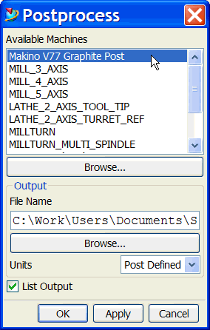

[ NB: Make sure that “WORDWRAP” (under FORMAT in Notepad) is turned OFF, otherwise the text will look garbled] Basically, each line of text in this file is made up of three sections, separated by commas. The start of every line contains the “text” which will appear as the name of the post-processor as it appears in NX. For this part of the entry, spaces are allowed. The next two entries define the path to the folder and the actual “tcl” and “def” files that contain the post-processor code. Don’t worry about the actual syntax; yours is going to be much simpler.

You can add a new line before or after the WIRE_EDM_4_AXIS post entry – it’s your choice. The new line should read:

Makino V77 Graphite Post, C:\UGPOSTS\Makino.tcl, C:\UGPOSTS\Makino.def

It is important that the text in italics reflect the actual path where YOU loaded your post files – also make sure that you have spelled the names of the post files correctly. Based on the example above, the modified template_post.dat file will look like this:

###############################################################################
# template_post config file - Event Handler and Definition files for
# Generic Machine
#
#
#
###############################################################################
Makino V77 Graphite Post,C:\UGPOSTS\Makino.tcl,C:\UGPOSTS\Makino.def
WIRE_EDM_4_AXIS,${UGII_CAM_POST_DIR}wedm.tcl,${UGII_CAM_POST_DIR}wedm.def WIRE_EDM_2_AXIS,${UGII_CAM_POST_DIR}wedm.tcl,${UGII_CAM_POST_DIR}wedm.def
MILL_3_AXIS,${UGII_CAM_POST_DIR}mill3ax.tcl,${UGII_CAM_POST_DIR}mill3ax.def
MILL_4_AXIS,${UGII_CAM_POST_DIR}m4bh.tcl,${UGII_CAM_POST_DIR}m4bh.def
MILL_5_AXIS,${UGII_CAM_POST_DIR}m5abtt.tcl,${UGII_CAM_POST_DIR}m5abtt.def
LATHE_2_AXIS_TOOL_TIP,${UGII_CAM_POST_DIR}lathe_tool_tip.tcl,${UGII_CAM_POST_DIR}lathe_tool_tip.def
LATHE_2_AXIS_TURRET_REF,${UGII_CAM_POST_DIR}lathe_turret_ref.tcl,${UGII_CAM_POST_DIR}lathe_turret_ref.def
MILLTURN,${UGII_CAM_POST_DIR}millturn_3axis_mill.tcl,${UGII_CAM_POST_DIR}millturn_3axis_mill.def
MILLTURN_MULTI_SPINDLE,${UGII_CAM_POST_DIR}millturn_4axis_mill.tcl,${UGII_CAM_POST_DIR}millturn_4axis_mill.def
TOOL_LIST(text),${UGII_CAM_POST_DIR}post_tool_list_text.tcl,${UGII_CAM_POST_DIR}post_shopdoc.def
TOOL_LIST(html),${UGII_CAM_POST_DIR}post_tool_list_html.tcl,${UGII_CAM_POST_DIR}post_shopdoc.def
OPERATION_LIST(text),${UGII_CAM_POST_DIR}post_operation_list_text.tcl,${UGII_CAM_POST_DIR}post_shopdoc.def
OPERATION_LIST(html),${UGII_CAM_POST_DIR}post_operation_list_html.tcl,${UGII_CAM_POST_DIR}post_shopdoc.def

6. Copy the Makino_Post_Options.tcl file into the ...\MACH\resource\postprocessor folder.

7. You can now post to this machine from the NX post-processor menu.

USING THE POST:

The Makino post works just like any other NX post; however, it has several options that may be set during run time. Each time the post is run it will present you with the following menu:

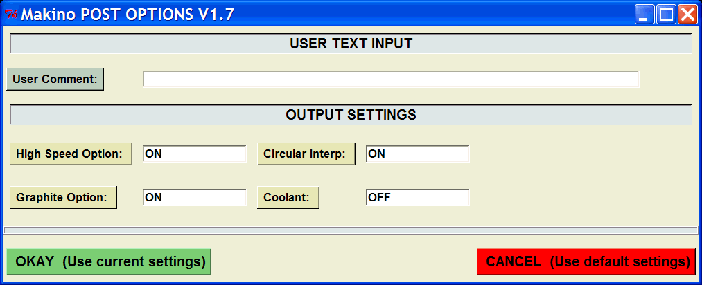

This menu is divided into 2 sections: the top half is for inputting user text, and the middle portion of the menu controls specific post-related output settings.

There are several ways with which a user may enter data into the various fields. As you can see, the assorted buttons/title-fields have different colors – this is as an aide to help the user remember how to interact with a particular button/option.

We’ll begin by looking at the first field, called User Comment; located at the very top of the menu. You will notice that this particular button has a dark-gray background – this means that you must type your comment into the empty field located to the right of this button. Any text entered into this field appears in the 3rd line of the post’s header, as shown here:

%
O100
N1 (Makino)
N2 (DATE: Tue Apr 04 2006 09:32:54PM)
N3 (This is where the user comment appears...)
N4 G90
HIGH SPEED OPTION

Selecting the High Speed Option with your left-mouse button presents you with two choices: ON or OFF. ON causes the post to output a G05 P10000 block while setting it to OFF suppresses this output:

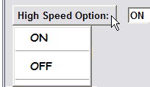
N16 G90 G01 G54 X.8601 Y-.1 F700.
N17 G43 Z2. H75
N18 Z.1
N19 Z0.0 F30.
N20 Y0.0
N21 X0.0

N16 G90 G01 G54 X.8601 Y-.1 F700.
N17 G43 Z2. H75
N18 M250
N19 G05 P10000
N20 Z.1
N21 Z0.0 F30.

CIRCULAR INTERP

The Circular Interp option allows you to turn circular interpolation ON or OFF:
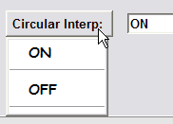
N20 Y-.325
N21 X-9.886
N22 G02 X-10.1503 Y-.1891 I0.0 J.325
N23 G03 X-10.7385 Y-.1386 I-.3156 J-.2258
N24 G02 X-11.6701 Y.7358 I-.4489 J.4551
N25 G03 Y1.8705 I-.653 J.5673
N26 G02 X-10.9366 Y2.3252 I.33 J.2866
N27 G03 X-10.2571 Y2.0652 I.4633 J.1929
N28 G02 X-9.4898 Y1.2622 I.2518 J-.5274
N29 G03 X-9.2 Y.7788 I.2898 J-.1548
N30 G02 Y-.325 I0.0 J-.5519
N31 G01 X-9.543
N20 Y-.325
N21 X-9.886
N22 X-9.9475 Y-.3201
N23 X-10.0069 Y-.3028
N24 X-10.0618 Y-.2745
N25 X-10.1105 Y-.2363
N26 X-10.1503 Y-.1891
N27 X-10.1985 Y-.1323
N28 X-10.2574 Y-.0864
N29 X-10.3239 Y-.0526
N30 X-10.3956 Y-.0322
N31 X-10.47 Y-.0258

GRAPHITE OPTION

The Graphite Option allows you to turn the vacuum option ON or OFF:
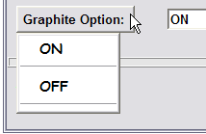
N13 T22
N14 M413
N15 S3056 M03
.
.
N30 M05
N31 M412
N32 M30

N13 T22
N14 S3056 M03
N15 G90 G01 G54 X.8601 Y-.1 F700.
.
.
N30 G28 G91 X0.0 Y0.0
N31 M05
N32 M30

COOLANT

The Coolant option allows you to select the coolant type. There are five possible choices: OFF, FLOOD, MIST, TAP or THROUGH:

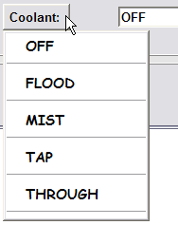
M08

M07

M08

M26

OKAY (Use current settings)

The OKAY button is used to apply any changes you made to the default settings so that they are used by the post-processor.

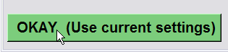

CANCEL (Use default settings)

Selecting the CANCEL button causes the post-processor to use the default settings and ignores any changes you may have made.



MAKINO POST OPTIONS – DEFAULT SETTINGS

The default settings for the Makino post are:

User-Comment = none
High Speed Option = ON
Circular Interp. = ON
Graphite Option = ON
Coolant = OFF

MACHINING-TIME OUTPUT CONVENTION

The Makino post also creates a separate file (in the same folder as the posted output file) containing the machining-time information for the operations being posted.

The machining-time filename follows the same naming convention as that of the posted filename: it uses the name you assign to the posted output and then adds the suffix “_MachTime” to the resulting numeric string and appends “.MAKIN” to this.

So, if the posted filename is 100.MAKIN, then the machining-time filename is 100_MachTime.MAKIN

The contents of the machining-time file typically look like this:

===============================================================================

MACHINE-TIME OUTPUT

Created on : Tuesday, April 04/2006 10:31:55PM
File Name : C:\Work\Users\Documents\POSTS\Makino\100_MachTime.MAKIN

===============================================================================

TOOL NAME: OPERATION NAME: MACHINE TIME:
-------------------------------------------------------------------------------
MILL_0.25 MAKINO_SAMPLE_OPERATION 0.25 MIN.
MILL_0.25 MAKINO_LINEAR_CUTCOMP_1 0.26 MIN.
MILL_0.25 MAKINO_CIRCULAR_CUTCOMP_1 0.27 MIN.
EM_0.1 MAKINO_LINEAR_CUTCOMP 0.51 MIN.
EM_0.5 MAKINO_CIRCULAR_CUTCOMP 0.52 MIN.
=============
TOTAL TIME: 1.82 MIN.

Upon completion, the NX information screen will display the machining time information as well as the posted output:

===============================================================================

MACHINE-TIME OUTPUT

Created on : Wednesday, April 05/2006 03:28:58PM
File Name : C:\Work\Users\Documents\POSTS\Makino\100_MachTime.MAKIN

===============================================================================

TOOL NAME: OPERATION NAME: MACHINE TIME:
-------------------------------------------------------------------------------
MILL_0.25 MAKINO_SAMPLE_OPERATION 0.25 MIN.
MILL_0.25 MAKINO_LINEAR_CUTCOMP_1 0.26 MIN.
MILL_0.25 MAKINO_CIRCULAR_CUTCOMP_1 0.27 MIN.
=============
TOTAL TIME: 0.79 MIN.

============================================================
Information listing created by : urc
Date : 4/5/2007 3:28:58 PM
Current work part : C:\Work\Users\Documents\POSTS\Makino\Makino Test.prt
Node name : --
============================================================

%
O100
N1 (Makino)
N2 (DATE: Wed Apr 05 2006 03:28:58PM)
N3 (This is where the user comment appears...)
N4 G90
N5 (MAKINO_SAMPLE_OPERATION)
N6 ( CUR. TOOL: T75)
N7 ( TOOL NAME: MILL_0.25)
N8 ( TOOL DIA.: 0.2500)
N9 ( TOOL RAD.: 0.0)
N10 G28 G91 Z0.0
N11 G28 G91 X0.0 Y0.0
N12 T75
N13 M06
N14 T22
N15 M413
N16 S3056 M03
N17 G90 G01 G54 X.8601 Y-.1 F700.
N18 G43 Z2. H75
N19 M250
N20 G05 P10000
N21 Z.1
N22 Z0.0 F30.
N23 Y0.0

Cutter-Comp Control:

Cutter compensation in NX is activated in an operation using a combination of settings. The first setting directly deals with enabling (turning on) cutter-comp:

1) Begin by selecting the Machine Control button of any Z-level machining operation (i.e. Face Mill, Planar Profile, Cavity Mill, etc.)

2) Next, select the Cutter Compensation button on the Machine Control menu.

3) Now from the Cutter Compensation menu, select Engage/Retract as your Cutcom settings:

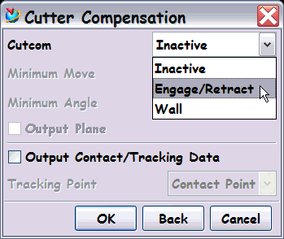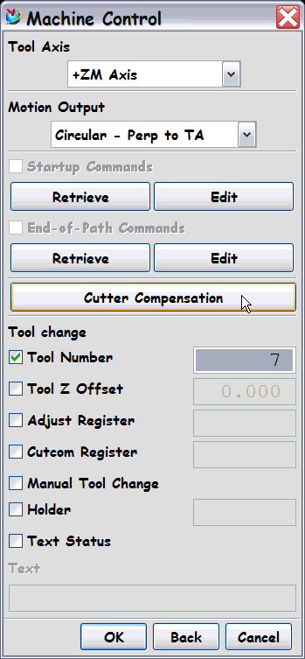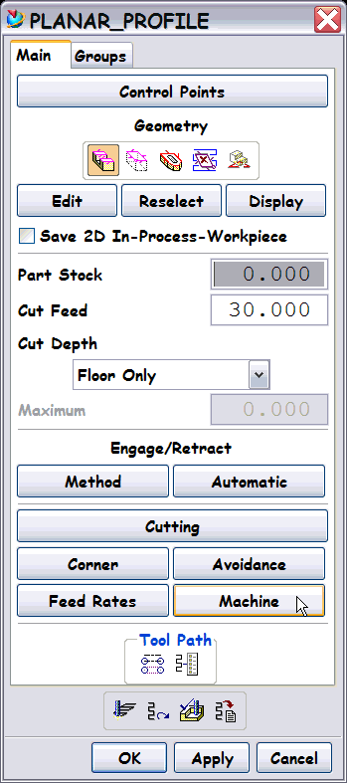
3
2
1

Cutter-Comp Control (cont’d):

In addition to turning cutter-comp on, you can also control the minimum linear move (Minimum Move) that is required by your controller in order to enable cutter compensation as well as the relative angle that the tool motion will use (Minimum Angle):

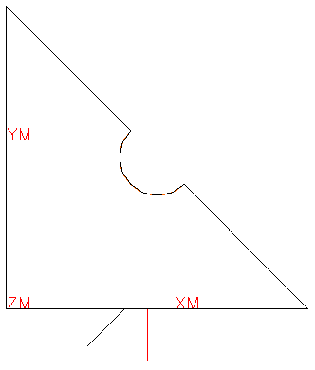
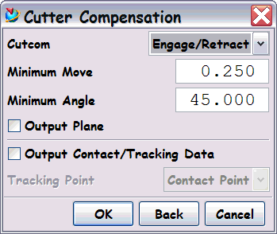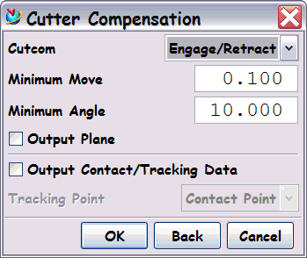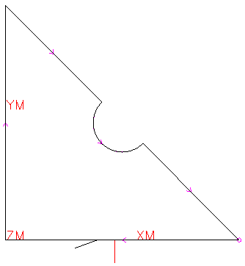
Minimum Angle = 10
= angle of departure
(if linear)
Minimum Move = 0.100
= length of motion…
Cutter-Compensation using a Linear Engage:
Minimum Angle = 45
= angle of departure
(if linear)
Minimum Move = 0.250
= length of motion…

Cutter-Comp Control (cont’d):

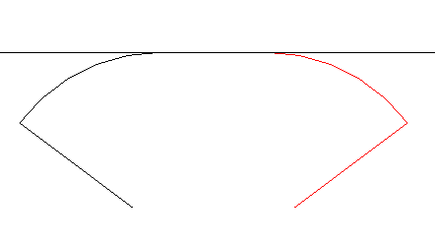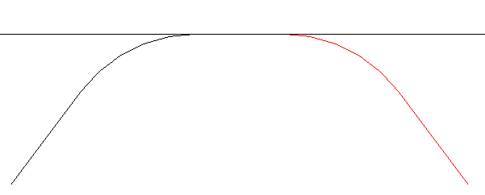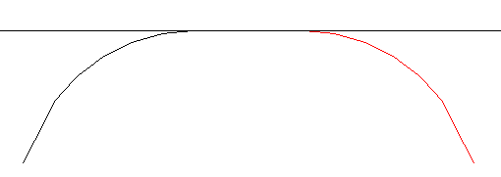
Cutter-Compensation using a Circular Engage:
Results when Minimum Move = 0.250 and Minimum Angle = 0 (engage and retract motion comes tangentially off of the arc).
Minimum Move = 0.100
= length of motion…
Minimum Angle = 10
degrees from tangency
Results when Minimum Move = 0.250 and Minimum Angle = 90 (engage and retract motion is 90° relative to tangent lines off of the arcs).
Cutter-Comp Control (cont’d):

As can be seen from the previous pages, you can also control how you want the tool to approach and depart from the part: you may use a linear or circular approach and departure.

Begin by ensuring that your Initial Engage and Final Retract settings are set to Automatic:

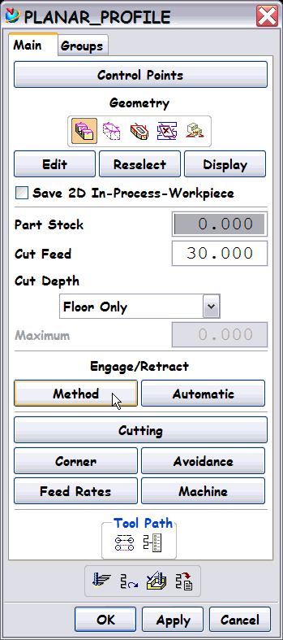
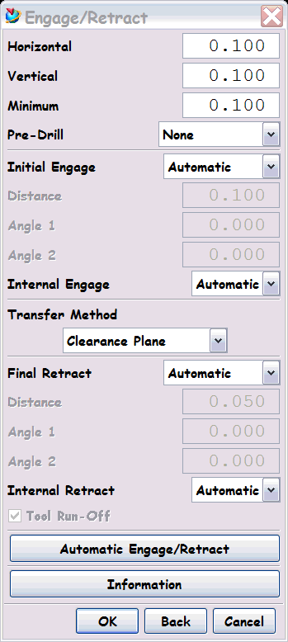
1
2
3

With these options set correctly you may continue to the Automatic Engage/Retract options menu. You can activate this menu directly from the Engage/Retract menu or you can select the Automatic button located on the main panel of the current operation:

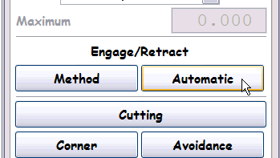
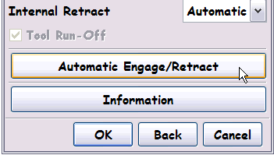
Main panel of current operation:
Engage/Retract menu:

Cutter-Comp Control (cont’d):

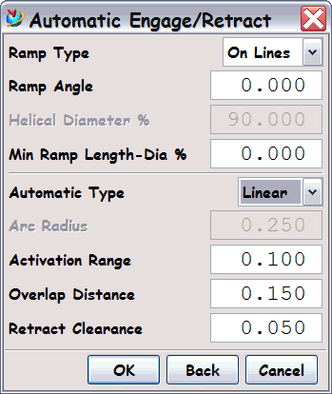
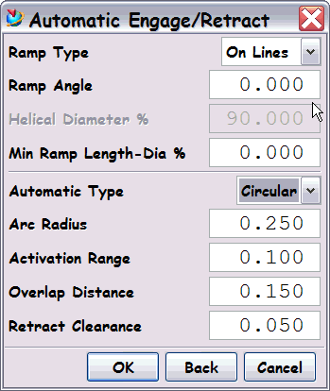
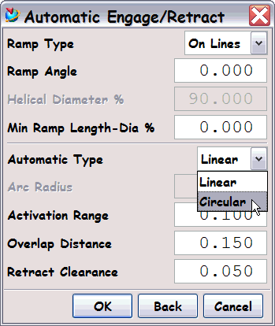
The lower portion of the Automatic Engage/Retract menu allows you to set the engage/retract motion:

Linear generates a straight line engage and a retract away from the wall, while Circular generates a move along an arc.

As some machine controllers are unable to apply cutter compensation to circular engage moves the system automatically adds a linear move before the circular engage move when you enable cutter compensation.

Arc Radius determines the radius of the path for Automatic circular engage and retract moves that the system uses.

The Activation Range is a value that you enter to define the maximum distance from the boundary that an Automatic circular or linear engage (or retract) can occur

The Overlap Distance assures full cleanup at the point where Automatic engage and retract moves occur. This value represents the total overlap distance - the paths overlap equally on each side of the original start point of the tool path.
Cutter-Comp Control (cont’d):

Retract Clearance is the distance a tool is lifted above the cutting plane for Automatic linear retract moves. When the system implements a linear retract, the tool is moved away from the part wall and floor at a 45° angle with respect to the cutting plane. NOTE: This is not used when cutter-comp is enabled.

The supplied test part (Makino Post Test Part.prt) includes five operations:

MAKINO_SAMPLE_OPERATION No cutter compensation
MAKINO_LINEAR_CUTCOMP_1 Cutter compensation enabled, linear approach/retract
with same tool as above operation.
MAKINO_CIRCULAR_CUTCOMP_1 Cutter compensation enabled, circular approach/retract
with same tool as above operation.
MAKINO_LINEAR_CUTCOMP Cutter compensation enabled, linear approach/retract
with 0.100” Dia. tool.
MAKINO_CIRCULAR_CUTCOMP Cutter compensation enabled, circular approach/retract
with 0.500” Dia. tool.

You can use this part as a reference for the different settings discussed in this manual.

